Implementation ScreenShot Document

- User LogIn

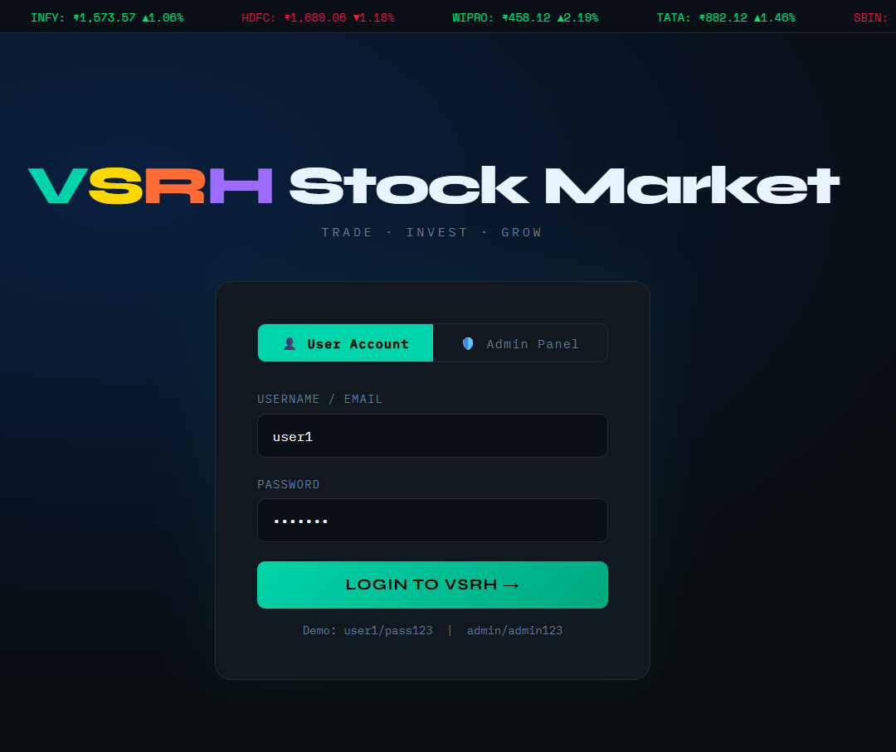

- User Dashboard

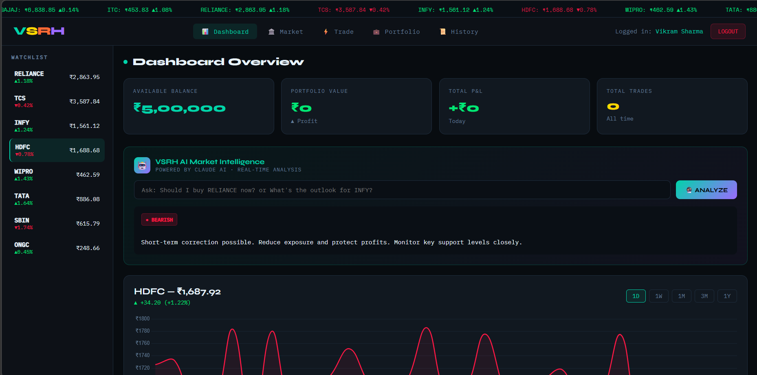

- View Ai Suggestion Box

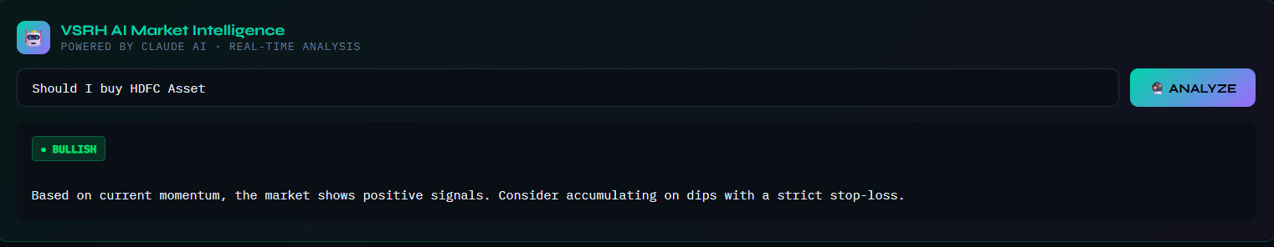

- Live Marketing

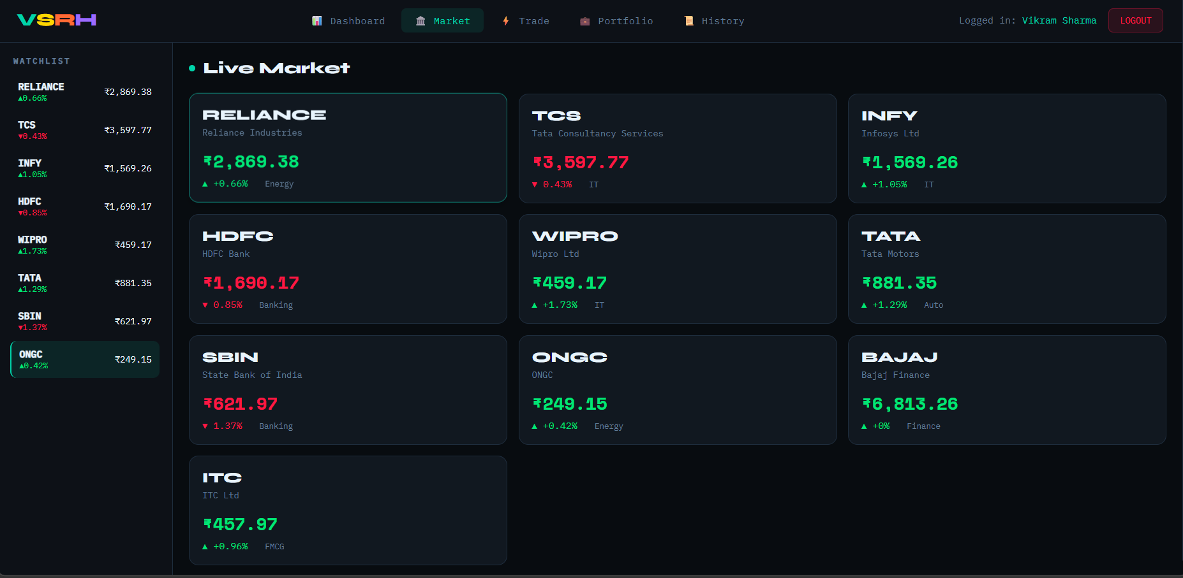

- Quick Trade

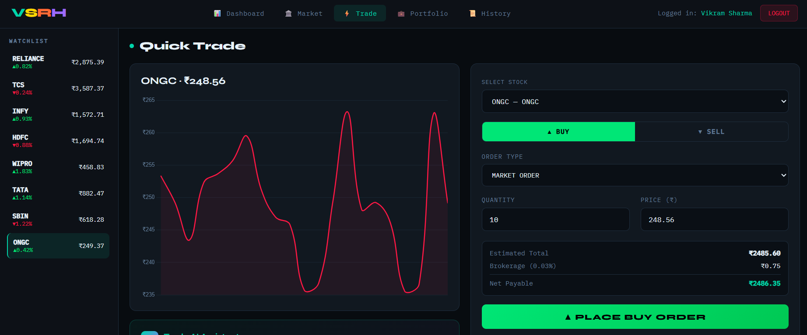

- Portfolio

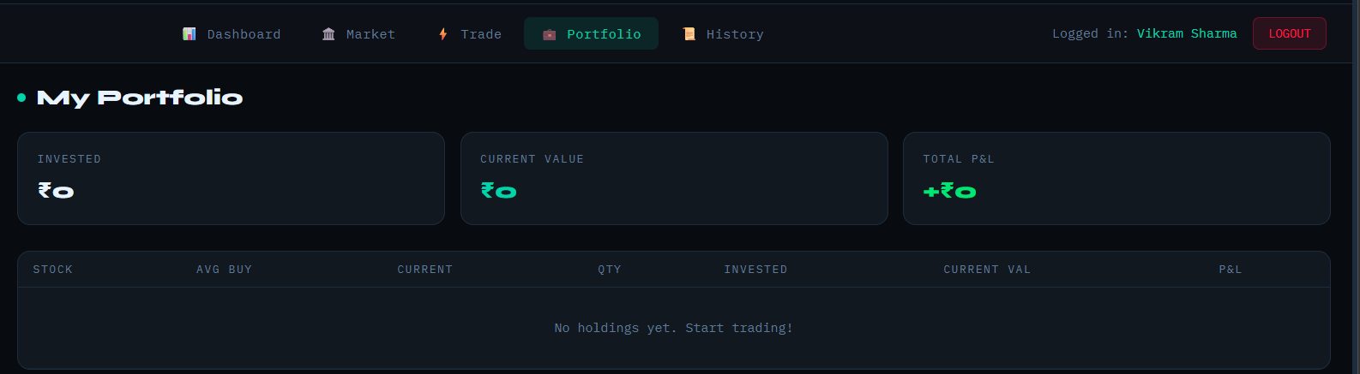

Administrative Portal

- Admin Credential

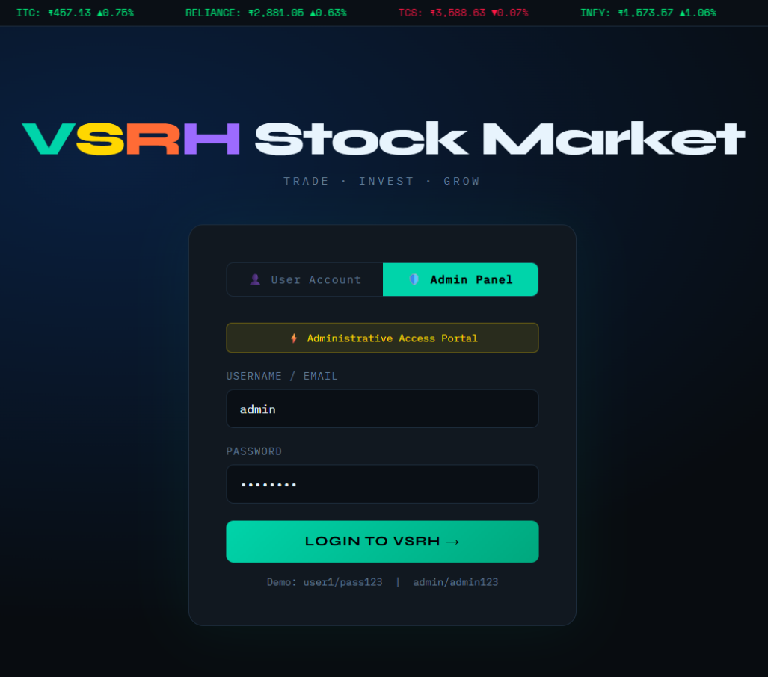

- Admin Monitor User

